**To install ros:**

**1- Download virtualbox**

https://www.virtualbox.org/wiki/Downloads

**2_ Install ubuntu version 20.04**

https://releases.ubuntu.com › 20.04Ubuntu 20.04.4 LTS (Focal Fossa (<https://releases.ubuntu.com/20.04)>)

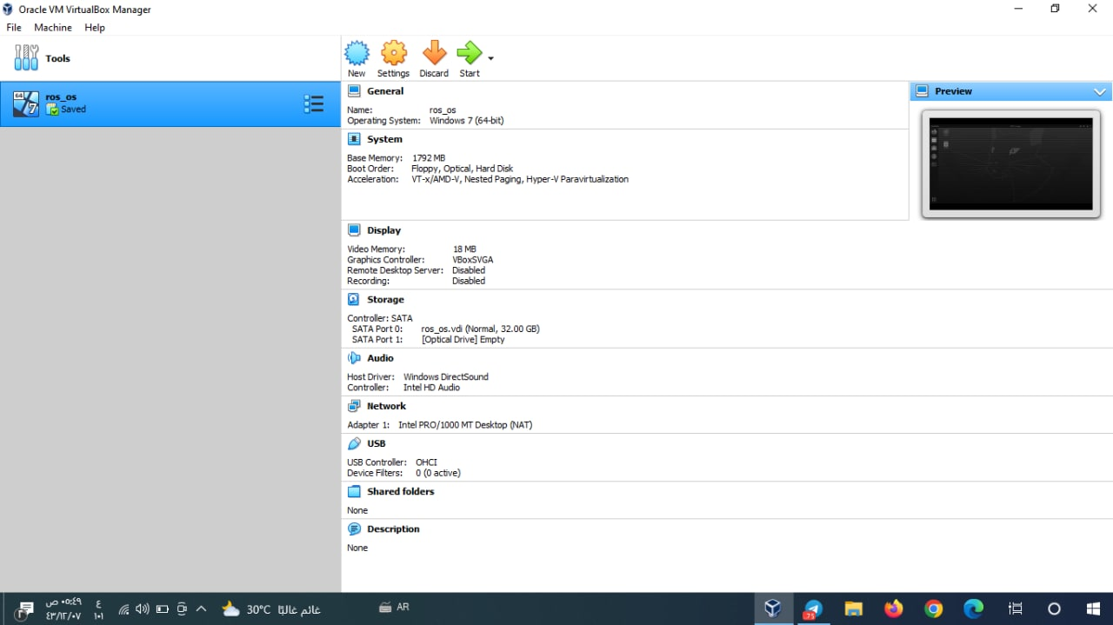

**3- Writing ros download codes on the Ubuntu system**

**Setup your sources.list:**

sudo sh -c 'echo "deb http://packages.ros.org/ros/ubuntu $(lsb_release -sc) main" > /etc/apt/sources.list.d/ros-latest.list'

Set up your keys:

sudo apt install curl # if you haven't already installed curl

curl -s https://raw.githubusercontent.com/ros/rosdistro/master/ros.asc | sudo apt-key add -

**Installation:**

sudo apt update

sudo apt install ros-noetic-desktop-full

sudo apt install ros-noetic-desktop

sudo apt install ros-noetic-ros-base

sudo apt install ros-noetic-PACKAGE

sudo apt install ros-noetic-slam-gmapping

apt search ros-noetic

Environment setup:

source /opt/ros/noetic/setup.bash

echo "source /opt/ros/noetic/setup.bash" >> ~/.bashrc

source ~/.bashrc

echo "source /opt/ros/noetic/setup.zsh" >> ~/.zshrc

source ~/.zshrc

**Dependencies for building packages:**

sudo apt install python3-rosdep python3-rosinstall python3-rosinstall-generator python3-wstool build-essential

Initialize rosdep:

sudo apt install python3-rosdep

sudo rosdep init

rosdep update

4-When all the above code is finished, type the **$roscore** command to make sure that the program installation has completed successfully.

5-This image shows you that the commands did not contain errors and the program was successfully downloaded and verified.

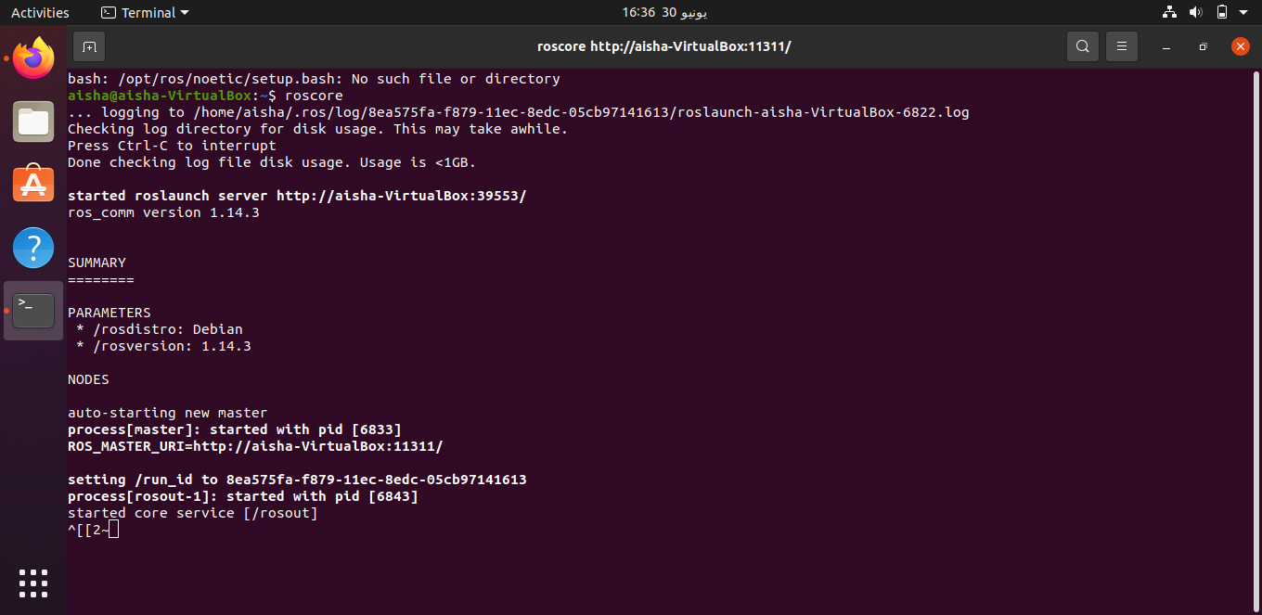

Eng: Aisha Rashed AL-zhrani.